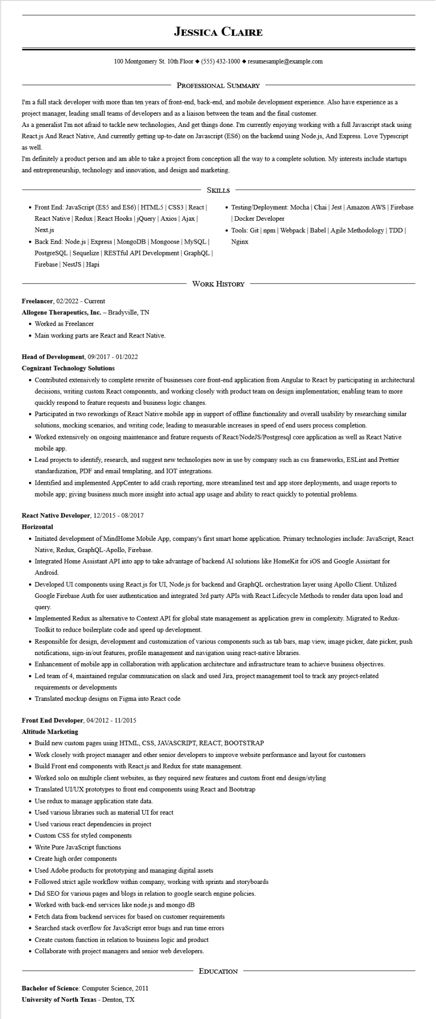
JESSICA CLAIRE
100 Montgomery St. 10th Floor (555) 432-1000◆ resumesample@example.com
PROFESSIONAL SUMMARY
I'm a full stack developer with more than ten years of front-end, back-end, and mobile development experience. Also have experience as a project manager, leading small teams of developers and as a liaison between the team and the final customer.
As a generalist I'm not afraid to tackle new technologies, And get things done. I'm currently enjoying working with a full Javascript stack using React.js And React Native, And currently getting up-to-date on Javascript (ES6) on the backend using Node.js, And Express. Love Typescript as well.
I'm definitely a product person and am able to take a project from conception all the way to a complete solution. My interests include startups and entrepreneurship, technology and innovation, and design and marketing.
• Front End: JavaScript (ES5 and ES6) | HTML5 | CSS3 | React React Native | Redux | React Hooks | jQuery | Axios | Ajax | Next.js
SKILLS
• Back End: Node.js | Express | MongoDB | Mongoose | MySQL | PostgreSQL | Sequelize | RESTful API Development | GraphQL | Firebase NestJS | Hapi
• Testing/Deployment: Mocha | Chai | Jest | Amazon AWS | Firebase |Docker Developer
⚫ Tools: Git | npm | Webpack | Babel | Agile Methodology | TDD | Nginx
WORK HISTORY
Freelancer, 02/2022 - Current
Allogene Therapeutics, Inc. - Bradyville, TN
• Worked as Freelancer
• Main working parts are React and React Native.
Head of Development, 09/2017 - 01/2022
Cognizant Technology Solutions
• Contributed extensively to complete rewrite of businesses core front-end application from Angular to React by participating in architectural decisions, writing custom React components, and working closely with product team on design implementation; enabling team to more quickly respond to feature requests and business logic changes.
• Participated in two reworkings of React Native mobile app in support of offline functionality and overall usability by researching similar solutions, mocking scenarios, and writing code; leading to measurable increases in speed of end users process completion.
• Worked extensively on ongoing maintenance and feature requests of React/NodeJS/Postgresql core application as well as React Native mobile app.
• Lead projects to identify, research, and suggest new technologies now in use by company such as css frameworks, ESLint and Prettier standardization, PDF and email templating, and IOT integrations.
• Identified and implemented AppCenter to add crash reporting, more streamlined test and app store deployments, and usage reports to mobile app; giving business much more insight into actual app usage and ability to react quickly to potential problems.
React Native Developer, 12/2015 - 08/2017
Horizontal
• Initiated development of MindHome Mobile App, company's first smart home application. Primary technologies include: JavaScript, React Native, Redux, GraphQL-Apollo, Firebase.
• Integrated Home Assistant API into app to take advantage of backend AI solutions like HomeKit for iOS and Google Assistant for Android.
• Developed UI components using React.js for UI, Node.js for backend and GraphQL orchestration layer using Apollo Client. Utilized Google Firebase Auth for user authentication and integrated 3rd party APIs with React Lifecycle Methods to render data upon load and query.
• Implemented Redux as alternative to Context API for global state management as application grew in complexity. Migrated to Redux- Toolkit to reduce boilerplate code and speed up development.
• Responsible for design, development and customization of various components such as tab bars, map view, image picker, date picker, push notifications, sign-in/out features, profile management and navigation using react-native libraries.
• Enhancement of mobile app in collaboration with application architecture and infrastructure team to achieve business objectives.
• Led team of 4, maintained regular communication on slack and used Jira, project management tool to track any project-related requirements or developments
• Translated mockup designs on Figma into React code
Front End Developer, 04/2012 - 11/2015
Altitude Marketing
• Build new custom pages using HTML, CSS, JAVASCRIPT, REACT, BOOTSTRAP
• Work closely with project manager and other senior developers to improve website performance and layout for customers
• Build Front end components with React.js and Redux for state management.
• Worked solo on multiple client websites, as they required new features and custom front end design/styling
• Translated UI/UX prototypes to front end components using React and Bootstrap
• Use redux to manage application state data.
• Used various libraries such as material UI for react
• Used various react dependencies in project
• Custom CSS for styled components
• Write Pure JavaScript functions
• Create high order components
• Used Adobe products for prototyping and managing digital assets
• Followed strict agile workflow within company, working with sprints and storyboards
• Did SEO for various pages and blogs in relation to google search engine policies.
• Worked with back-end services like node.js and mongo dB
• Fetch data from backend services for based on customer requirements
• Searched stack overflow for JavaScript error bugs and run time errors
• Create custom function in relation to business logic and product
• Collaborate with project managers and senior web developers.
Bachelor of Science: Computer Science, 2011 University of North Texas - Denton, TX
EDUCATION

